主标题：Android HF RFID Reader
副标题：HT540-HF Rugged Android HF RFID Scanner
Key features:
56 MHz RFID reader supporting ISO 14443A & 15693, NFC, and ISO 7816 protocols
1D/2D barcode scanning capabilities
2.0GHz Octa-Core processor for fast performance
Android 10.0 operating system
Dual-band Wi-Fi and Bluetooth for seamless connectivity

Android HF RFID Reader-1
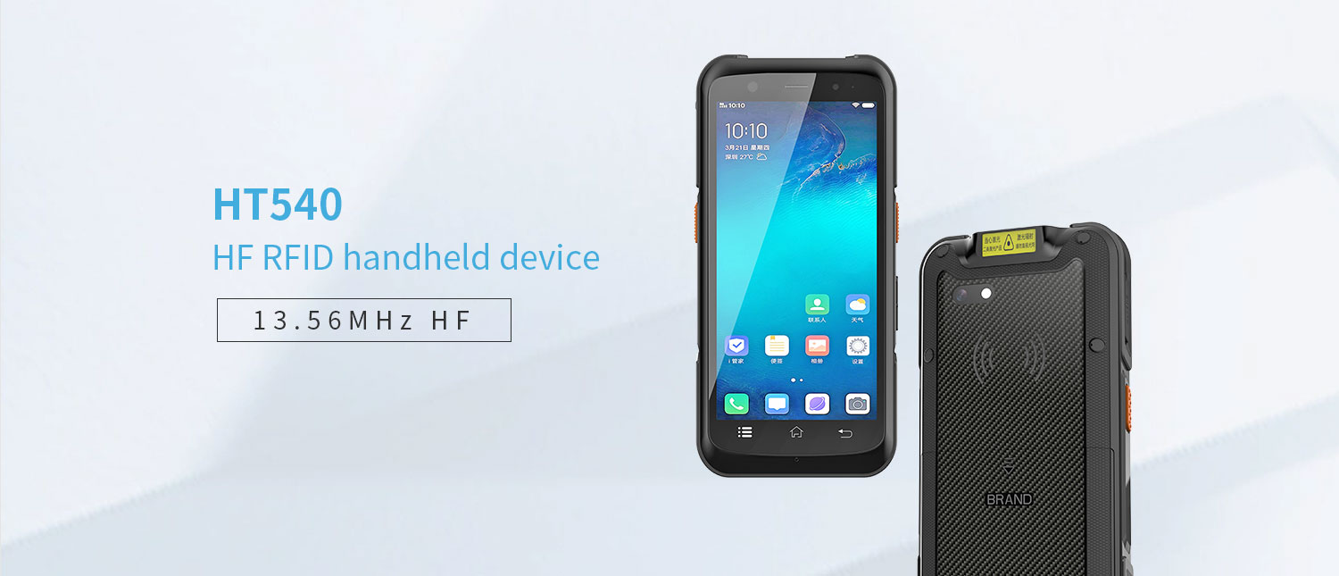
HT540-HF Android HF RFID Reader is a robust device designed for efficient mobile data collection. It supports 13.56 MHz RFID reading with ISO 14443A, 15693, and NFC protocols, and features 1D/2D barcode scanning and GPS. Powered by a 2.0GHz Octa-Core processor and Android 10.0, it offers fast performance with options for 2GB/16GB or 4GB/64GB storage. The reader is equipped with Wi-Fi, Bluetooth, and a 13 MP rear camera for versatile applications in industries requiring reliable, real-time data capture and processing.

Android HF RFID Reader-2
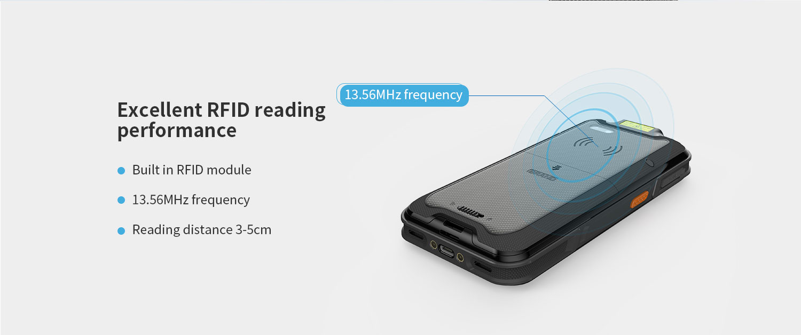
The HT540-HF handheld Android hf rfid reader terminal has a built-in RFID 13.56 MHz module.
Working frequency: 13.56MHz Protocol: ISO14443 and ISO15693
Other modules: Other modules can be customized
Android HF RFID Reader-3
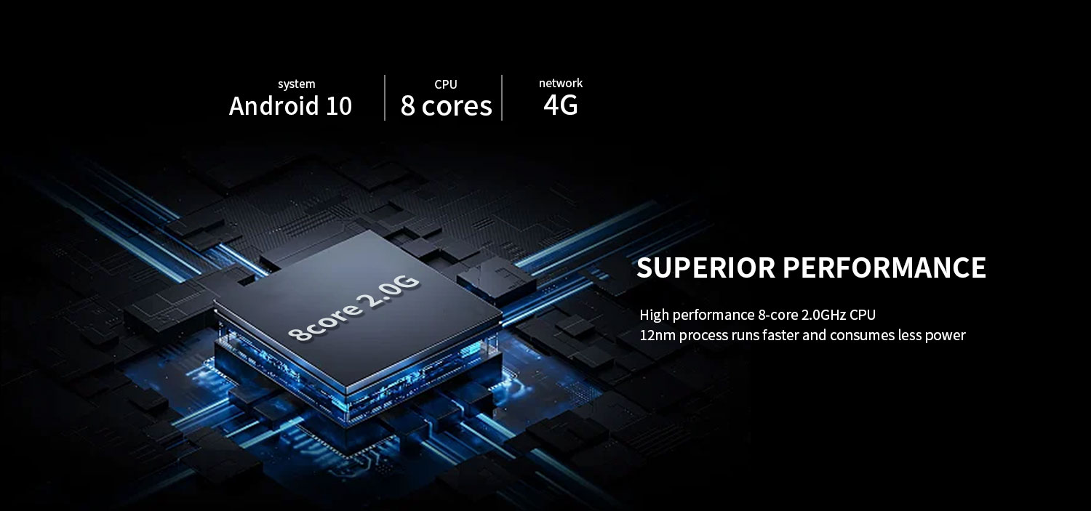
High performance CPU
MT6762 CPU: Experience the powerful performance of MediaTek MT6762, designed specifically for seamless multitasking on your PDA device.
Standard memory 2G+16G, optional 4GB+64GB: Use a high memory warehouse scanner to provide ample storage space for all your applications and files.

Android HF RFID Reader-4
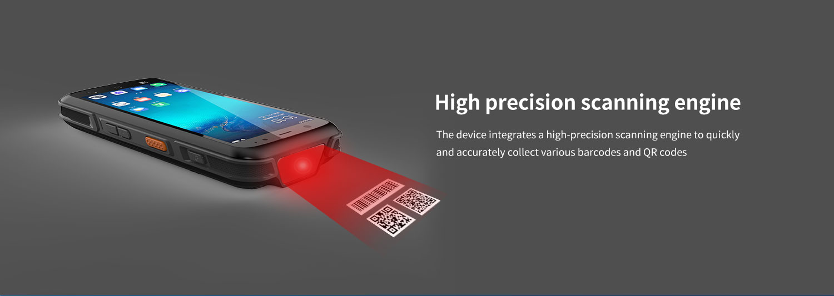
scanning engine - optional
The HT540-HF Android HF RFID handheld terminal supports the optional TMS-E60 scanning engine, with high brightness LED providing exposure assisted lighting, allowing for quick barcode recognition even in completely dark conditions. TMS-E60 provides laser aiming indicator patterns to assist users in aiming at targets, promote barcode recognition, and improve recognition efficiency. Capable of reading the most commonly used barcodes in the retail, logistics, and healthcare industries, such as Code 11, Code 128, PDF417, EAN codes, etc. It even supports scanning damaged barcodes and screen barcodes.
Supports optional Honeywell HS7 (with a motion tolerance of up to 6 meters/second (236 inches/second), capable of effectively reading mobile barcodes)
Android HF RFID Reader-5
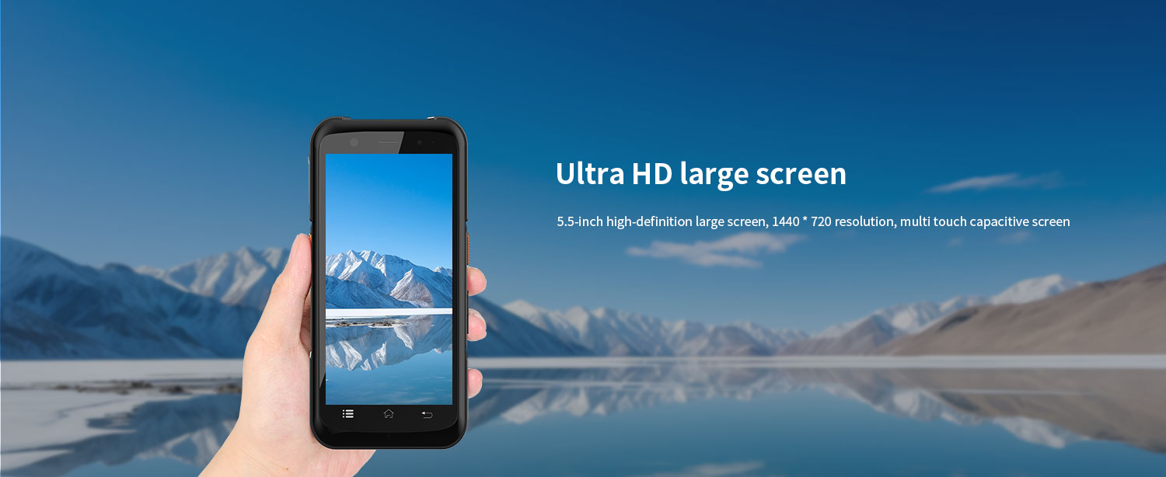
The HT540-HF Android HF RFID Reader is equipped with a 5.5-inch touchscreen, which allows for normal keyboard operation even when hands are wet or gloves are worn, making it more widely applicable.

Android HF RFID Reader-6

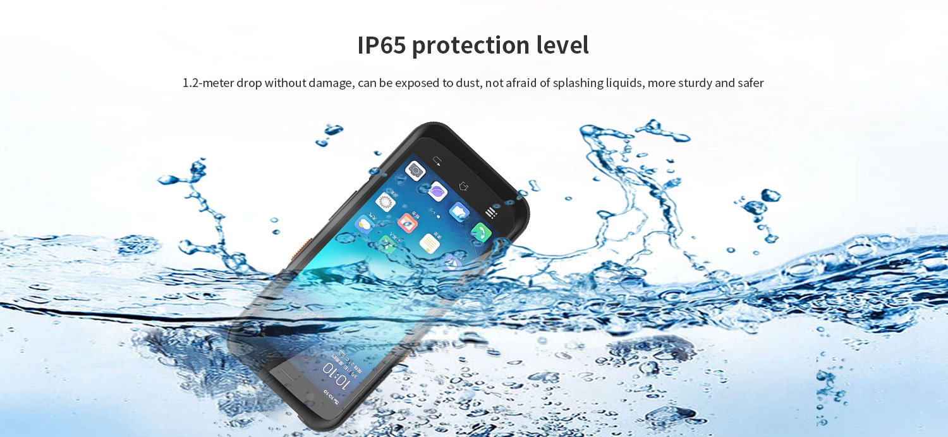
IP65 protection level
1. Dustproof: Fully enclosed design to prevent dust from entering and ensure the safety of internal components.
2. Waterproof: This HT540-HF Android handheld mobile RFID reader has splash proof function, but should not be immersed in water.

The HT540-HF Android hf rfid scanner provides enhanced security, better performance, and a more user-friendly mobile operating system. Provide SDK development toolkit, demonstration software, and source code, support secondary development, and provide API interface customization.
Attention: We can help you test your application before making bulk purchases.

HT540-HF is a portable multifunctional handheld HF RFID reader that can meet different application needs. Android 10 operating system, equipped with high-performance 8-core 2.0G clock speed processor, 5.5-inch high-definition large screen, 13 million camera; 2GB+16GB memory, 4G+64GB optional. Supporting multiple optional functions: barcode scanning (optional scanning head), RFID module (optional), PSAM IP65 protection level, adopting dual color injection molding process, with strong industry adaptability, widely used in various application fields such as logistics, retail, warehousing, medical, power, one card, parking fees, municipal engineering, etc., helping users quickly achieve information management and improve enterprise operation efficiency.
Android HF RFID Reader-7
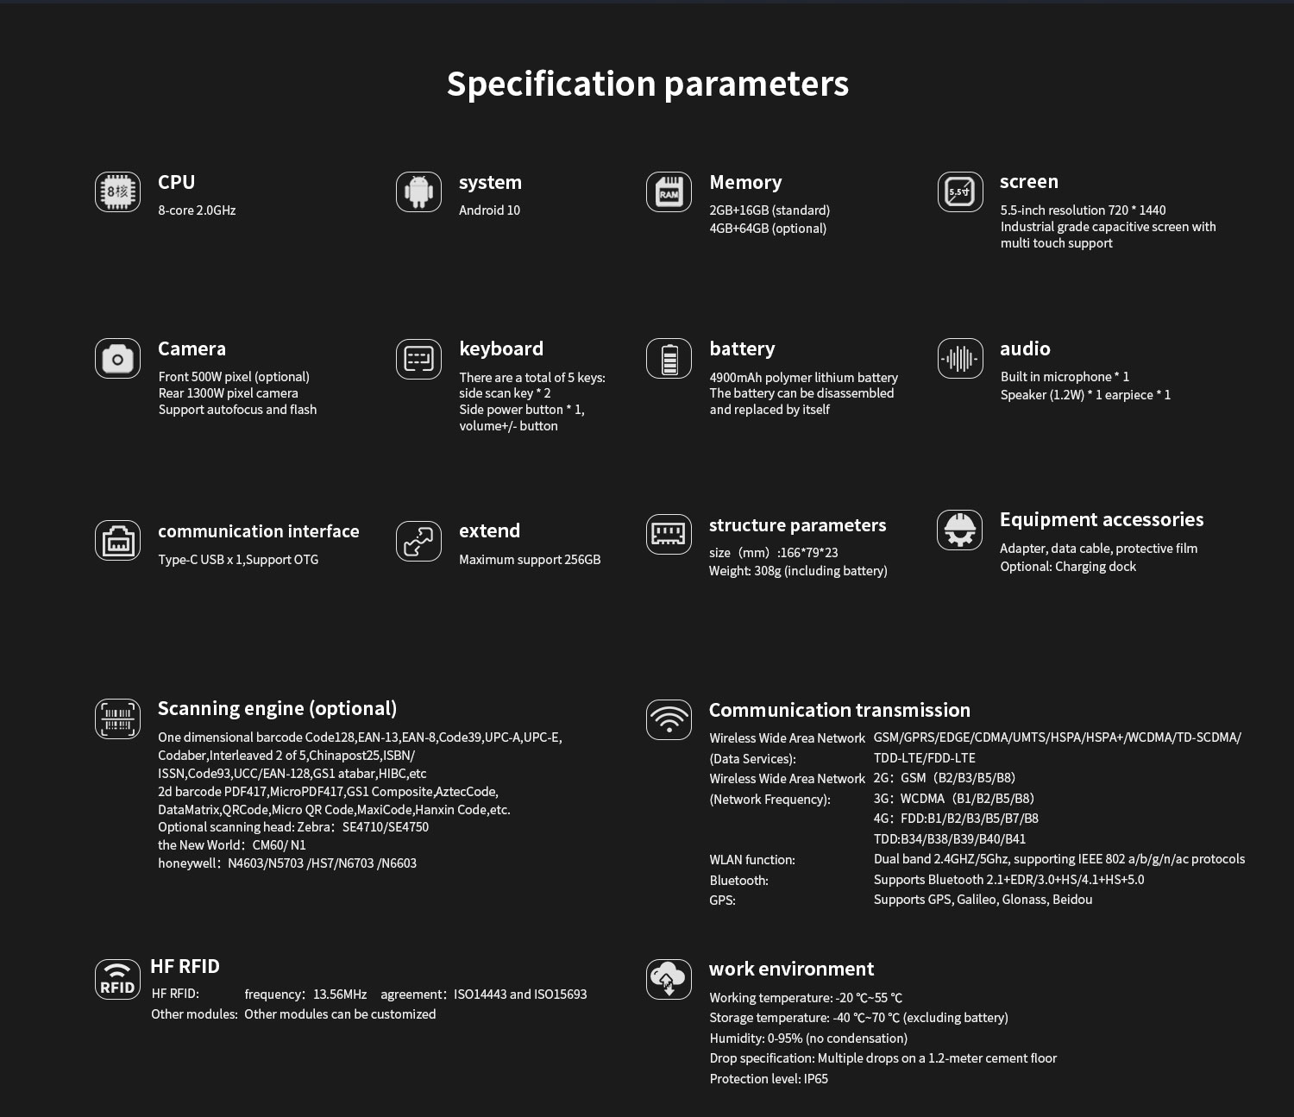
HARDWARE CUSTOMIZATION
1: Nameplate Logo Customization
2:Packaging Custom Design
﻿
SOFTWARE CUSTOMIZATION
1:Boot Screen Customization
2:System Function Hiding
3:Built-in Customer App
4:Customer App Auto-launch
5:Platform Software Integration
6:Fixed MAC Address
7:Download Prohibition
﻿8:USB Disablement
﻿9:APP Installation and Uninstallation Control
10:Pre-installed APK
﻿11:Camera Control
12:Provide System Signing Files

frequently asked questions
Q: Are you the original manufacturer?

A: Yes, we are the original manufacturer. We have our own brand LQYCIT. All of our products have complete patented ID/MD designs, hardware and software, molds, and assembly are all completed by our own team.

Q: Can you pre install our software?

A: Yes, we can pre install your software.

Q: What is the minimum order quantity?

A: We accept standard product orders starting from one unit. If necessary, we can even customize your logo. For OEM, our sales team will review the detailed requirements and confirm the minimum order quantity.

Q: Can we get free samples?

A: Sorry, we usually do not provide free samples. If the customer confirms the specifications and pricing, they can first order samples for testing and evaluation.

Q: How to place an order and make payment?

A: We accept wire transfers (bank transfers), Alibaba online payments, and Western Union remittances.

Q: What is the warranty period for your products?

A: We offer a 12-month warranty after shipment.

Q: How long is the delivery time?

A: The production delivery cycle is about 3-10 days, depending on the requirements. The delivery time through DHL/UPS/FedEx/TNT is approximately 3-5 working days. For some remote areas, the transportation time may be longer.

Q: How to fix equipment problems?

A: We will provide online technical support to solve problems. For hardware issues, we can ship parts or components for customers to install (if they have technicians), or we can ship them back to us for repairs.

